Recommendation Algorithms

Algorithms

Collaborative filtering

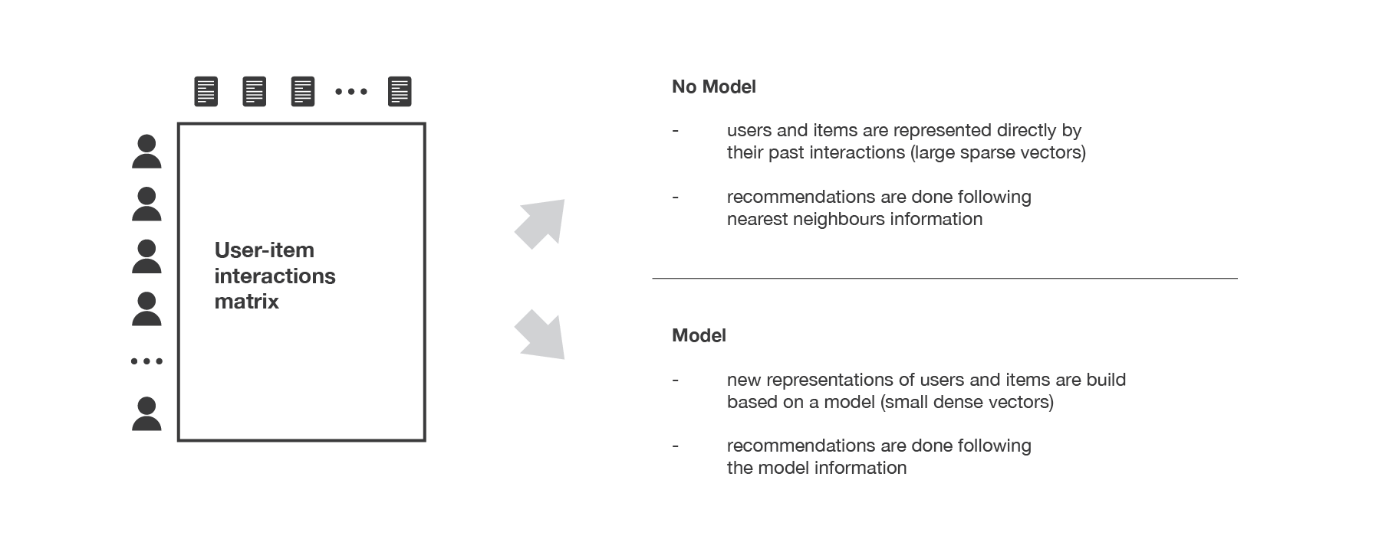

However, as it only consider past interactions to make recommendations, collaborative filtering suffer from the “cold start problem”.

Three classical collaborative filtering approaches:

memory based methods (user-user)
This method is said to be “user-centred” as it represent users based on their interactions with items and evaluate distances between users.

we can keep the k-nearest-neighbours to our user and then suggest the most popular items among them (only looking at the items that our reference user has not interacted with yet)

memory based methods(item-item)
To make a new recommendation to a user, the idea of item-item method is to find items similar to the ones the user already “positively” interacted with.
Two items are considered to be similar if most of the users that have interacted with both of them did it in a similar way. This method is said to be “item-centred” as it represent items based on interactions users had with them and evaluate distances between those items.

model based approach (matrix factorisation)

user-movie rating matrix.

Content-based
Based on user features and item features.
In content based methods, the recommendation problem is casted into either a classification problem (predict if a user “likes” or not an item) or into a regression problem (predict the rating given by a user to an item). In both cases, we are going to set a model that will be based on the user and/or item features at our disposal (the “content” of our “content-based” method).

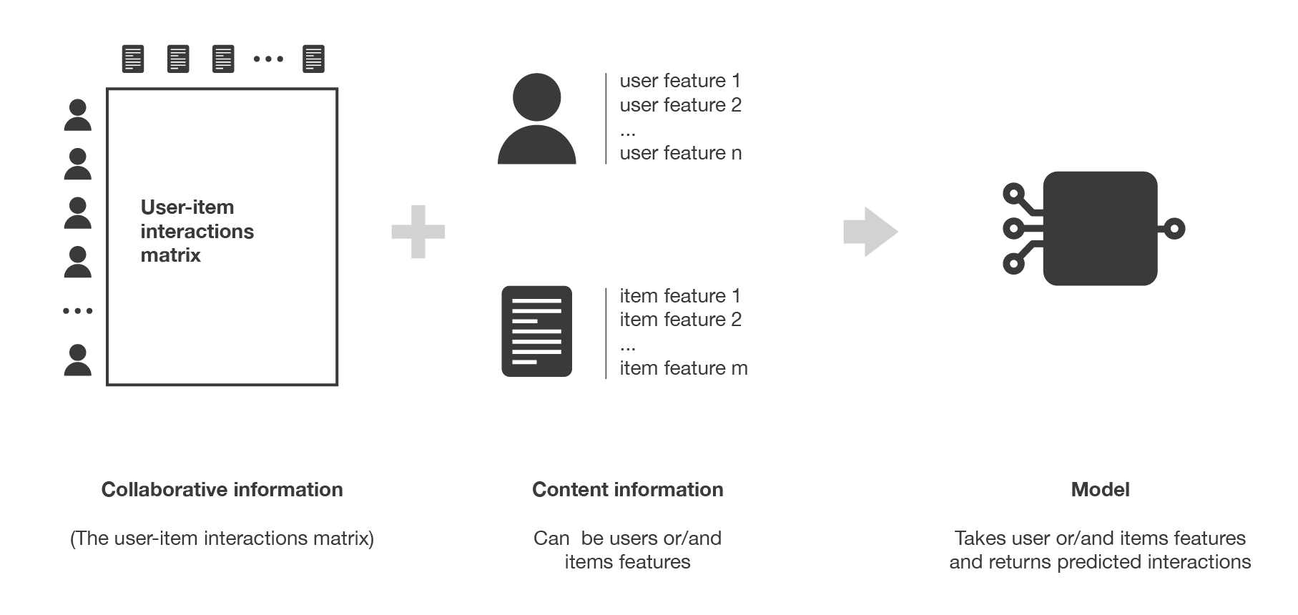
Item-centred
modelling, optimisations and computations can be done “by item”.
“what is the probability for each user to like this item?” (or “what is the rate given by each user to this item?”, for regression).

Item-centred Bayesian classifier
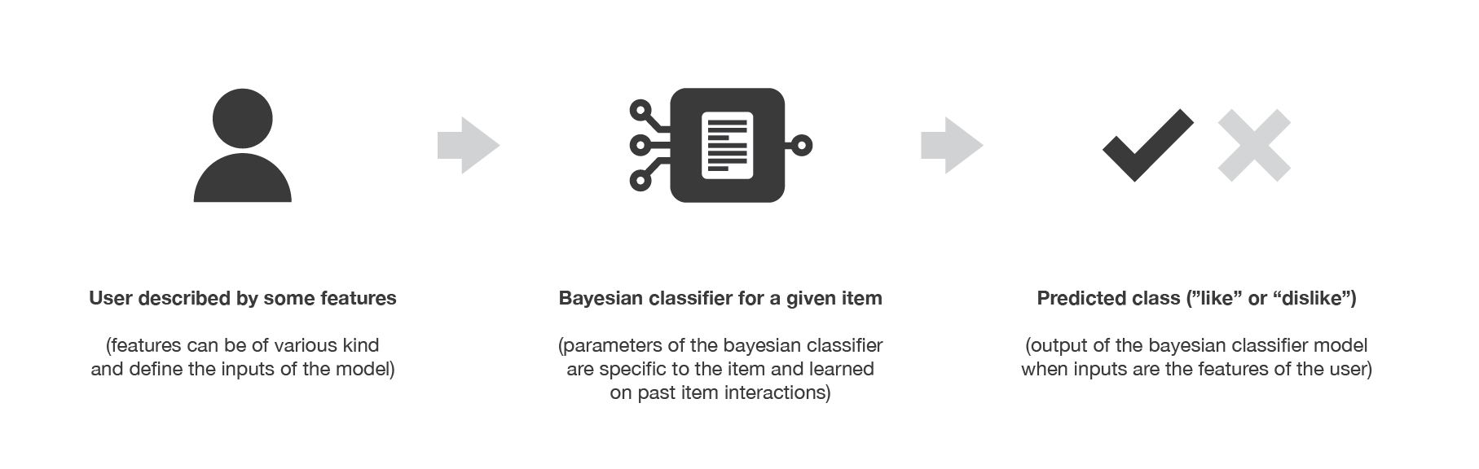
Illustration of the item-centred content based Bayesian classifier.

User-centred
modelling, optimisations and computations can be done “by user”.
“what is the probability for this user to like each item?” (or “what is the rate given by this user to each item?”, for regression).

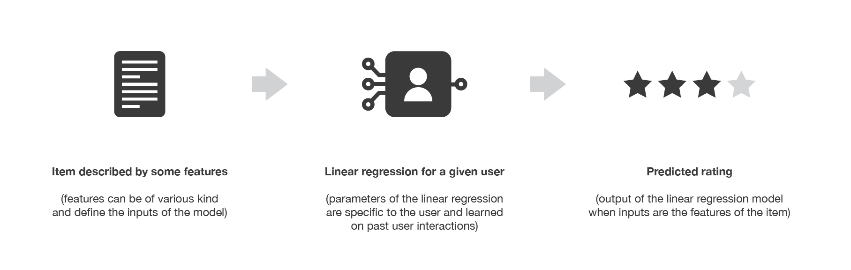
illustration of the user-centred content based regression.

Image Similarity

Hybrid Methods
Mix content-based and collaborative filtering approaches.

References
- Introduction to recommender systems
- https://en.wikipedia.org/wiki/Collaborative_filtering
- https://towardsdatascience.com/building-a-personalized-real-time-fashion-collection-recommender-22dc90c150cb

